Automated Theorem Proving (ATP) deals with the development of computer programs which

show that some statement (the conjecture) is a logical/syntactic consequence of a set of statements

(the axioms and the hypotheses).

These automated systems were used in a lot of domains such as:
- mathematics (EQP, Otter, Geometry Expert),
- software generation (KIDS, AMPHION),
- software verification (KIV, PVS),
- hardware verification (ACL2, HOL, ANALYTICA).

Dedicated (educational) automated theorem provers:
- based on semantic tableaux method: 3TAP, pTAP, leanTAP, Cassandra;
- based on resolution method: OTTER, PCPROVE, AMPHION, Jape;
- based on semantic trees + Herbrand theorem: HERBY;
- based on model elimination calulus: SETHEO;

Modeling reasoning
Example1 (homework)
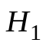. All hummingbirds are richly  colored.  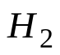. No large birds live on honey.  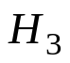. Birds that do not live on honey  are dull in color.  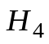. Piky is a hummingbird.  Conclusions:  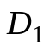. All hummingbirds are small.  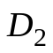. Piky is a small bird and  lives on honey.  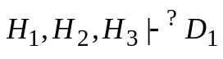and 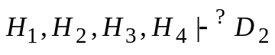. | 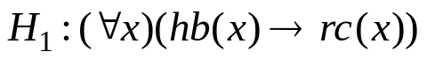  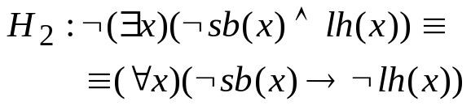  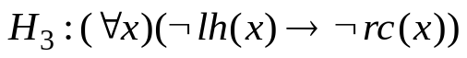  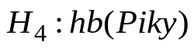  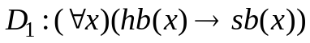  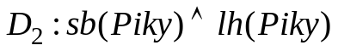

Example2

. Every child loves Santa.  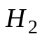. Everyone who loves Santa  loves any reindeer.  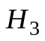. Rudolf is a reindeer,  and Rudolf has a red nose.  . Anything which has a red nose  is weird or is a clown.  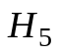. No reindeer is a clown.  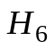. Scrooge does not love  anything which is weird.  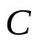. Scrooge is not a child.  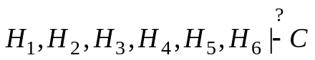. | 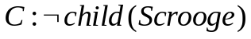  where:  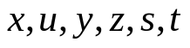 are variables,  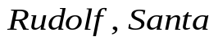, 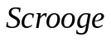 are constants,  -  unary predicates  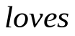 is a binary predicate

We apply a refutation proof method: general predicate resolution.
The clausal normal forms corresponding to the hypotheses and
the negation of the conclusion are as follows:
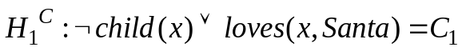
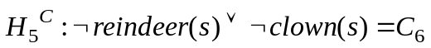
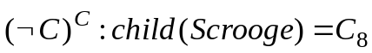

To the set of clauses 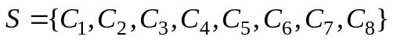, general predicate resolution is applied.
(!homework)

Example 3
Hypotheses:
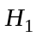: Any Computer Science student likes logic and likes any programming
language.
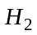: Someone who likes logic is a Computer Science student or a Philosophy
student.
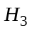: Java is a programming language.
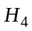: John doesn’t like Java but he likes logic.
Conclusion:
C: John is a Philosophy student but he is not a Computer Science student.

The hypotheses and the conclusion are translated into first-order language. Symbols used:
- 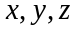 are variables;
- logic, 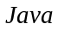, 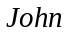 are constants,
- 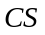 and are unary predicate symbols with the meanings:
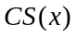:’ is a Computer Science student’
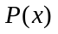:’ is a Philosophy student’
- 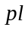 is a unary predicate, 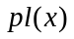: ’ is a programming language’
- 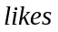 is a binary predicate, 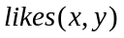: ’ likes ’
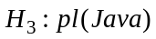
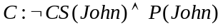
We transform the hypotheses and the negation of the conclusion into clausal normal forms:
, 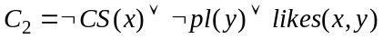
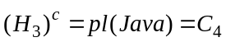
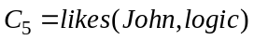, 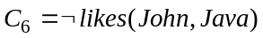
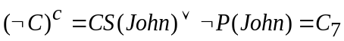

We apply linear resolution to the set 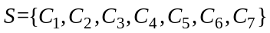of clauses, with 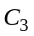 as the top clause.
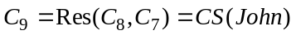
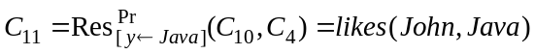
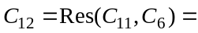

The linear refutation process is represented graphically as follows:

□
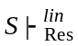□, therefore is an inconsistent set and based on the hypotheses we conclude that:
‘John is a Philosophy student but he is not a Computer Science student’.

Example 4 Modeling reasoning in geometry using predicate logic

The domain is the set of all the lines in a plane.
We use variables: x, y, z to denote arbitrary objects (lines) and
constants: ,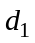,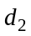to denote constant objects (lines).
Hypotheses:
: If is perpendicular to then intersects .
: If is parallel to then doesn’t intersect .
: If is perpendicular to and is perpendicular to then is parallel to .
: is perpendicular to .
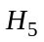: is perpendicular to .
Conclusion.
: does not intersect .

Check whether the conclusion is derivable from the set of hypotheses
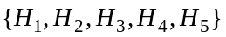 using a syntactic proof method.

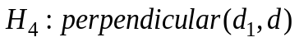
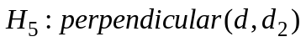
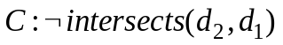

We have to add predicate formulas which express the properties
of symmetry for the geometric relations:.

The properties of reflexivity for 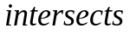, and transitivity for 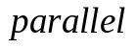 must be also added:
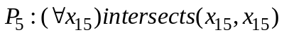

The clausal normal forms of the hypotheses: 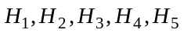, the negation of the conclusion
and the properties: 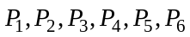 are as follows:
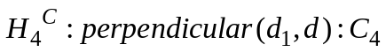
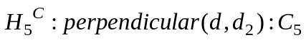
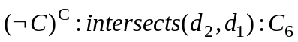
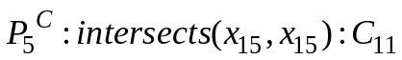

We apply general resolution to the set of clauses: 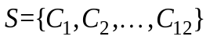.
The following resolvents are obtained during the resolution process:
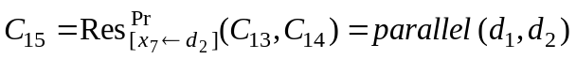
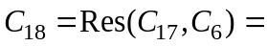□

The empty clause was derived from the set of clauses, so is inconsistent and the deduction 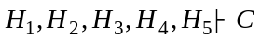 holds.
The conclusion ‘ does not intersect ’ is valid, based on the validity of the hypotheses.
Example 6. Mathematical reasoning modeling in algebra.
Prove: “If every element of a group 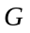 is its own inverse, then is an Abelian group”.

We will introduce the axioms, 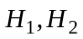 which define the group, the hypothesis,
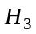: “every element of the group is its own inverse”, and
the conclusion : “the group is an Abelian group”.

Mathematical language:
- associativity
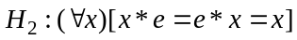 - - neutral element
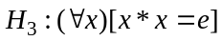- every element is its own inverse
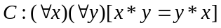 - conclusion: is an Abelian group

First-order logic language:
We use the ternary predicate symbol , with the meaning: 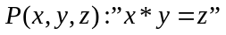. ‘e’ is a constant.
The formulas 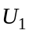 and 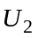 correspond to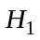:
The formulas 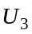 and 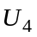 correspond to :
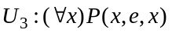, 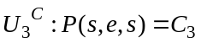
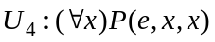, 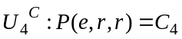
The formula 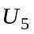 corresponds to :
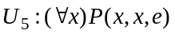, 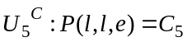
The formula 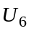 corresponds to the conclusion:
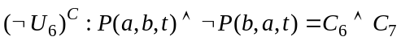 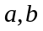 – Skolem constants

In the clauses we renamed some of the free variables.
Checking whether 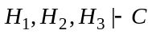 was reduced to checking the inconsistency
of the set of clauses: 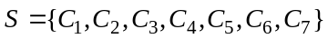.
The refutation from S is presented below. At each application of the resolution rule, the literals resolved upon from the parent clauses are underlined.

, 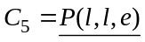
- C₈
, 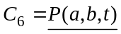
- C₉
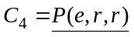, 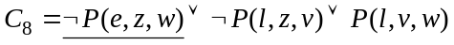
- C₁₀ 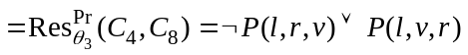
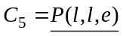,
- C₁₁ 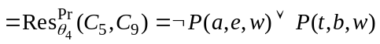
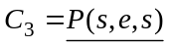, 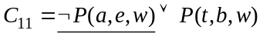
- C₁₂ 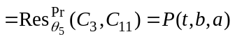,
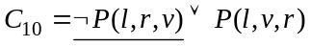, 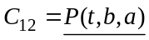
- C₁₃ 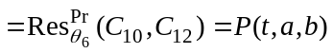
,
- C₁₄
,
- C₁₅ 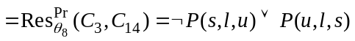
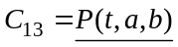, 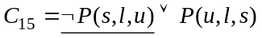
- C₁₆ 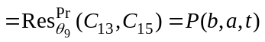
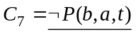, 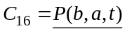
- C₁₇ 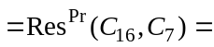□, so the set is inconsistent and 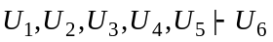.

We conclude that the statement “If every element of a group is its own inverse, then is an Abelian group” is valid.

The resolution process is represented graphically by the following binary tree.

□

